**Logistics Flow Chart**

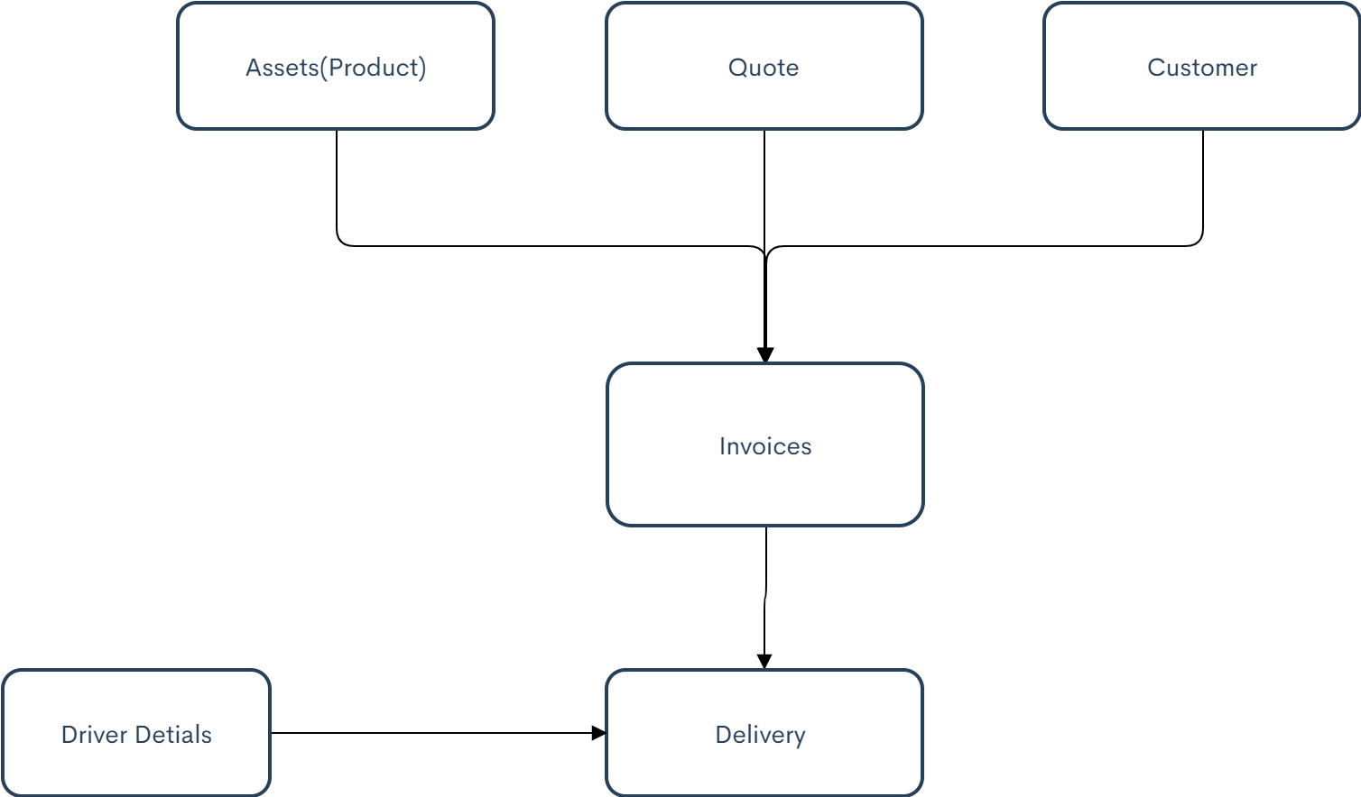

**Customer Management**

Create Customer information page using LWC component. Getting all details like Name,

Number, Email , Pickup and Delivery Location.

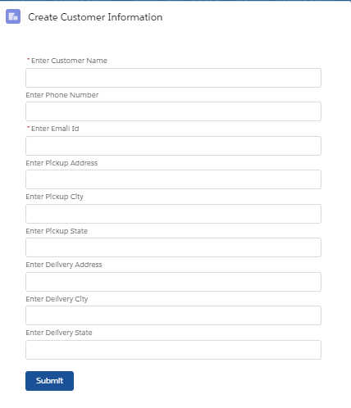

**Asset Management**

Asset create from product with the use of standard functionality.

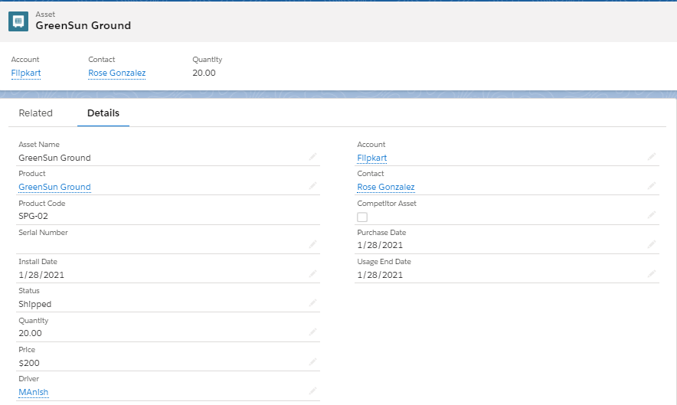

**Quote Management**

Quote create with the use of standard functionality. The parameter we have used its based on city or kilometer (Not fully support) based on customer delivery locations.

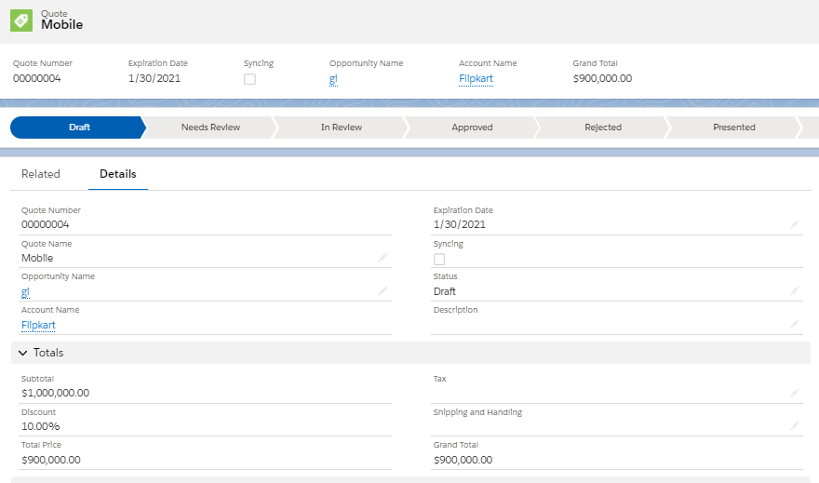

**Invoice Management**

Invoice created with the help of Customer info, Assets and Quote . Based on Kilometer we are calculating charges for delivery product and driver.

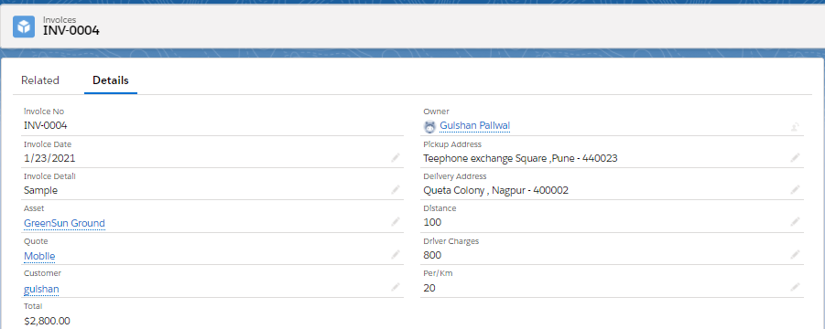

Below is the PDF page (Visualforce Page) for showing details invoice and calucalation for Invoice and driver charges.

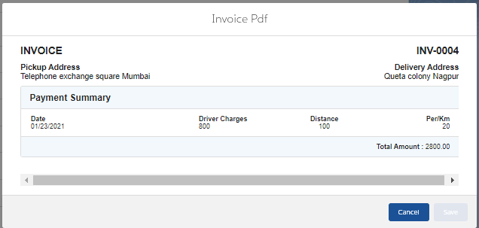

**Driver Management**

Store the information of driver (Name, Phone Number and Vechile Number)

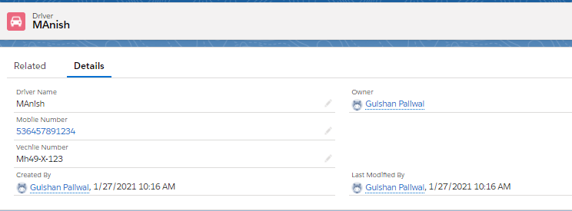

**Dashboard for Delivery Status**

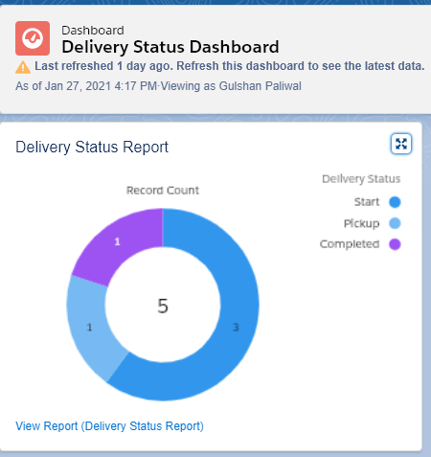

**Notification Task(Process Builder)**

Based on delivery we are providing email alert (Delivery status, Expected Date and Driver details)

